Exercise I.
- Assuming ideal op amp, find the voltage gain 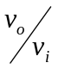 and input resistance 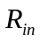 of each of the circuits in Figure P1.1.
- Figure P1.2 shows a modified version of instrumentation amplifier. Show that the differential voltage gain is given by 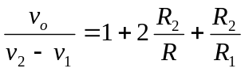.
- Figure P1.3 shows a two-order low-pass filter. Show that the transfer function is given by 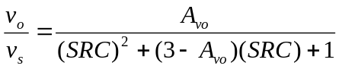 where 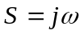 and 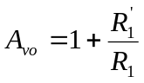.
- For the circuit in Example 2.2, what gain results when all resistors are equal? An extension of this circuit is shown in Figure P1.4 determine its gain.
- Figure P1.5 shows a signal source connected to the input of an amplifier. Here 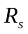is the source resistance, and 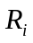and 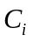 are the input resistance and input capacitance, respectively, of the amplifier. Derive an expression for 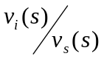 and show that it is of the low-pass type. Find the –3 dB frequency for the case 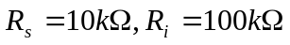, and 

